Evaluation of Luxury Hotel Brands:

An Image-Based Analysis

|  |  |  |
| --- | --- | --- |
| Adnan Nazmuddin  SCET, MIT WPU  Pune, India  1032190097@mitwpu.edu.in | Venkatesh Shirbhate  SCET, MIT WPU  Pune, India  1032190785@mitwpu.edu.in | Sahil Vakkani  SCET, MIT WPU  Pune, India  1032191630@mitwpu.edu.in |
| Vidushi Sharma  SCET, MIT WPU  Pune, India  1032191366@mitwpu.edu.in | **Dr. Nitin Pise**  SCET, MIT WPU  Pune, India  Nitin.pise@mitwpu.edu.in |  |

***Abstract- This project explores luxury hotel brands by analyzing images shared on social media platforms. It aims to understand how these visual elements influence consumer evaluations. The study uses deep learning techniques and trains five different Convolutional Neural Network (CNN) architectures to classify images accurately. By analyzing 9,251 consumer pictures from TripAdvisor, the research highlights the importance of non-textual elements in consumer experiences, such as the restaurant, bedroom, and bathroom within the hotel. The study demonstrates the practical application of deep learning algorithms in monitoring social media platforms and understanding consumer perceptions. The findings provide valuable insights for luxury hotel managers to improve brand management strategies and enhance guest experiences. By combining image analysis and deep learning, this project offers a fresh perspective for improving consumer evaluation of luxury hotel brands and helps hotel managers better understand customer preferences and expectations.***

***Keywords : Deep Learning, CNN, Image Processing, CV, Image Classification.***

# Introduction

The increasing demand for luxury brands is adding complexity to the luxury marketplace, presenting new challenges for brand managers [1]. Success in brand management relies on understanding consumers' expectations and effectively responding to generate profitability [2]. Luxury hotel management has gained attention from scholars and practitioners in both brand management and tourism management literature, while social media monitoring offers insights into consumer behavior and brand engagement. Furthermore, user-provided photos on the Internet are becoming increasingly important in product evaluation [3]. In this context, brand managers in luxury hotel management face the task of capturing and leveraging their brand's essence to create meaningful connections with customers. In the digital age, social media platforms provide a powerful avenue for consumers to share experiences, opinions, and visual content, offering valuable insights into their evaluations of luxury hotel brands. This research project aims to explore the impact of user-generated photos on consumer evaluations of luxury hotel brands, utilizing advanced techniques in AI, ML, Deep Learning, Image Processing, and Computer Vision to analyze and interpret these visual cues. By comprehensively understanding the attributes that significantly influence consumer evaluations, brand managers can refine their strategies and deliver exceptional guest experiences, effectively positioning luxury hotel brands for success in a highly competitive market.

## Problem Statement

In the luxury hotel industry, brand managers face the challenge of understanding and meeting consumer expectations to drive brand success and profitability. With the increasing importance of social media platforms and user-generated content, such as photos shared by tourists, there is a need to explore the impact of visual content on consumer evaluations of luxury hotel brands. Traditional research methods often rely on textual feedback and reviews, which may not fully capture the experiential and aesthetic aspects conveyed through visual content. Therefore, the problem at hand is to investigate the attributes that significantly influence consumer evaluations of luxury hotel brands based on user-provided photos and to develop a deep learning-based approach to analyze and interpret these visual cues. By addressing this problem, the study aims to bridge the gap in understanding the role of visual content in shaping consumer perceptions and provide valuable insights for brand managers to enhance their strategies and elevate guest experiences in the luxury hotel domain.

## Domain of Project

This project utilizes AI, ML, Deep Learning, Image processing, and Computer Vision to comprehensively analyze user-generated photos in the luxury hotel domain. AI techniques, including ML and Deep Learning, train models to classify and interpret visual data. Deep Learning algorithms, specifically CNNs, extract features and patterns from images for a nuanced understanding of user-shared content. Image processing techniques enhance data quality, and Computer Vision performs tasks such as image recognition and attribute extraction. The integration of these technologies provides valuable insights into the relationship between user-generated photos and consumer evaluations of luxury hotel brands. It pushes the boundaries of traditional research methods and enhances understanding of visual aspects impacting brand perception in the luxury hotel industry.

## Aim of the project

## This project addresses the growing significance of user-generated photos in shaping consumer evaluations of luxury hotel brands. Traditional research methods often overlook the experiential and aesthetic dimensions conveyed through visual content, relying primarily on textual feedback. To bridge this gap, the project aims to investigate and understand the attributes that significantly impact consumer evaluations based on user-provided photos. By leveraging AI, ML, Deep Learning, Image Processing, and Computer Vision techniques, the project enables the comprehensive analysis and interpretation of large volumes of visual data, providing a deeper understanding of the role and impact of visual content in the luxury hotel domain.

The project follows a systematic approach to achieve its objectives. It begins by collecting user-generated photos from platforms like TripAdvisor, which serve as a valuable source of visual data related to luxury hotel experiences. These photos undergo preprocessing using image processing techniques to enhance their quality and standardize inputs for analysis. Deep learning models, particularly Convolutional Neural Networks (CNNs), are then trained to classify and interpret the visual attributes within the photos. The project's findings have practical implications for luxury hotel brand managers, enabling them to refine their brand management strategies based on a deeper understanding of the visual elements that influence consumer evaluations. Additionally, the insights gained can inform targeted marketing campaigns, tailored promotions, and personalized experiences to effectively engage with consumers in the digital era.

# Literature Survey

Previous studies have made efforts to explore the factors influencing consumer satisfaction with hotel brands using various research methods. Questionnaires have been commonly used to gather consumer feedback [4], while online rating systems and sentiment analysis have been employed to assess consumer sentiment [5]. Additionally, the impact of social media interactions on consumer perceptions has been examined [6].

Recent research has also highlighted the influence of destination images on tourists' behavior throughout their travel journey [7]. Images, in particular, have emerged as preferred content in online posts, offering a virtual glimpse into hotel features and enhancing attractiveness [8]. Social media platforms such as Instagram and Facebook play a significant role in branding destinations, allowing for the curation of specific visual representations through filters and digital effects [9].

Consequently, brand managers have integrated social media into their marketing strategies, recognizing its fundamental role in their campaigns [10]. The presence on platforms like Facebook enables firms to attract new customers through electronic word-of-mouth communication and engage with existing ones, serving as a direct channel for brand interactions [11]. Moreover, the utilization of fan pages on social media contributes to reputation building, increased awareness, and the dissemination of corporate identity [12][13][14].

Specialized tourism platforms like TripAdvisor and Booking have become crucial resources for travelers, providing access to a vast amount of online reviews to inform travel decisions. TripAdvisor, in particular, stands as the largest travel platform, hosting millions of reviews and pictures of hotels, restaurants, and attractions [15]. User-provided photos, shared on such platforms, allow tourists to showcase their meaningful tourism experiences and receive appreciation from others, including strangers [16]. Consequently, researchers have recognized the value of these user-generated photos as rich data sources for tourism research.

However, despite the growing interest in social media analytics and the utilization of user-provided photos in understanding travel patterns [17], the specific contribution of these photos to the communicative effect of online reviews remains understudied. How user-provided photos influence users' perception of review quality compared to textual cues and other user-generated content is yet to be empirically examined. Thus, there is a need to develop new approaches, particularly leveraging deep learning techniques in computer image processing, to effectively process and interpret these user-provided product photos. The application of deep learning in natural language processing and image processing holds great potential in addressing the challenges associated with user-generated content on the internet and gaining a deeper understanding of the information value of online reviews in the hospitality and tourism domain.

## Limitations of the existing research

There are some identifiable limitations in the existing research.

First, picture analysis has only concentrated about the interior elements (bedroom, living room, dinner room, restaurant etc.,)of the hotel as mentioned above, but didn’t consider the exterior elements such as parking area, swimming pool, and spa etc.

Second, The existing research only considered the picture analysis using the Logistic Regression machine learning algorithm, but doesn’t consider the text associated with picture which may be positive or negative feedback.

# Research Methodology

## Dataset

To conduct our research, we utilized a publicly available dataset consisting of 73,993 images that depicted various areas of hotels. These images were categorized into 15 distinct classes.

|  |  |
| --- | --- |
| 1. Balcony | 9.  Living Room |
| 1. Bar | 10. Lobby |
| 1. Bathroom | 11. Patio |
| 1. Bedroom | 12. Pool |
| 1. Business Center | 13. Restaurant |
| 1. Dining room | 14. Sauna |
| 1. Exterior | 15. Spa |
| 1. Gym |  |

The dataset used in this study consisted of approximately 5,100 images per class, except for the sauna and business center classes, which had around 4,000 images each. To ensure reliable results, the dataset was divided into training and validation sets, with 20% of images from each class reserved for validation to prevent overfitting.

To expand the dataset and evaluate the model's performance on real-world hotel images, a separate test dataset was created through web scraping. This involved collecting 9,251 images from ten hotels in London, UK, selected based on similar prices and a minimum of 300 traveler-uploaded photos on TripAdvisor. The test dataset comprised independent images not present in the original dataset, allowing for the evaluation of the model's performance on diverse and real-world hotel images. By incorporating both the original dataset and the web-scraped test dataset, the deep learning model was trained and evaluated on a wide range of hotel images, ensuring its effectiveness in accurately classifying images based on their visual appearance.

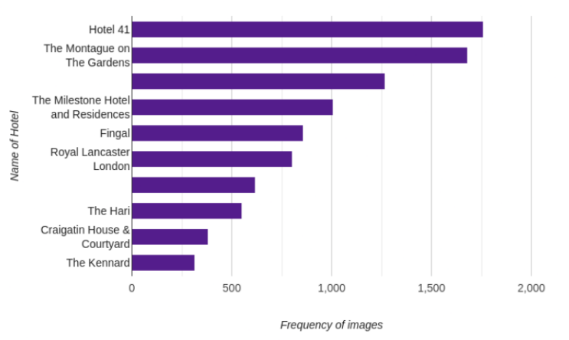

Fig 1. Test Dataset Distributio

## Data Collection Methodology

In order to gather a comprehensive dataset for the project, a web scraping methodology was employed to collect data from TripAdvisor. TripAdvisor is a popular travel website that contains a wealth of user-generated content, including hotel reviews, ratings, and traveler photos. By extracting this data, valuable insights can be obtained to enhance the hotel-image classification project.

The web scraping process involved the development of a Python script utilizing the Selenium WebDriver and related libraries. The script was designed to automate the data extraction process from the TripAdvisor website. The following steps were followed during the data collection methodology:

### Selection of Target Website: TripAdvisor

### Configuration of Web Scraping Script: The Python script was developed to leverage the capabilities of the Selenium WebDriver

### Script Execution: The script was executed to initiate the web scraping process.

### Data Extraction: The script accessed each hotel's webpage using the Selenium WebDriver and extracted relevant information such as hotel reviews, ratings, and traveler photos.

### Hotel Information: The script extracted details such as the hotel's name and the number of photos associated with it.

### Traveler Photos: The script expanded the traveler photos section and retrieved the available photos. It selected the first photo to initiate the extraction process.

### Review Details: For each photo, the script retrieved the associated review title, review text, and rating. This information provided insights into the experiences and opinions of hotel guests.

### Data Storage: The extracted data was stored in a structured format, such as a CSV file.

### Completion and Data Analysis: Once the script completed the data extraction process for all the specified hotel URLs, it terminated the web driver and provided a summary of the total number of photos extracted.

By employing web scraping techniques, the project was able to gather a substantial amount of data from TripAdvisor, including hotel reviews, ratings, and traveler photos. This data served as a valuable addition to the project's dataset, enabling the development and evaluation of a robust hotel-image classification model.

## Data Source

TripAdvisor serves as an ideal data source for this project due to its popularity, extensive user base, and the wealth of information available for each hotel listing. The website's review sections contain valuable insights into the quality, features, and visual appearance of hotels, which are crucial for training and evaluating the hotel-image classification model

It is important to note that the data collection process adhered to TripAdvisor's terms of service and policies. The scraping script was developed to retrieve information publicly available on the website, without interfering with the normal functioning of the platform or violating any privacy guidelines.

## Data Preprocessing

In order to prepare the training data for the hotel-image classification project, a series of preprocessing steps were applied to ensure data quality and compatibility with the deep learning model. The following methods were employed during the data preprocessing stage

### Rescaling:

Since the training data consisted of images with varying aspect ratios and sizes, a stage-dependent rescaling policy was implemented. During the training stage, each image was rescaled to have a minimum side of 256 pixels while preserving the original aspect ratio. This approach allowed for retaining the spatial information of the images while ensuring that the input size remained within the model's trainable limits.

### Data Augmentation:

To mitigate the risk of overfitting and enhance the model's ability to generalize, data augmentation techniques from the Albumentations library were utilized. Albumentations provides a comprehensive set of augmentation transformations specifically designed for image data. By applying augmentations such as random rotations, flips, translations, changes in brightness, and contrast variations, the training data was augmented to simulate real-world image variations. This augmented dataset helped improve the model's robustness and its ability to handle diverse input images.

By combining the rescaling and data augmentation techniques, the training data was effectively normalized and diversified, making it suitable for training the hotel-image classification model. These preprocessing steps ensured that the model could effectively learn from images with different sizes, aspect ratios, and realistic variations commonly found in hotel photographs.

## Model:

System Analysis and Architecture

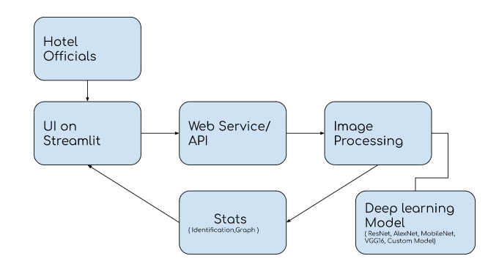

Fig 2. System Architecture

Explanation of the architecture:

1. Hotel Officials: The end-users of the system are hotel officials who interact with the system to upload hotel images and obtain predictions.

2. Web Service/API: This component acts as an interface for hotel officials to communicate with the system. It receives the uploaded hotel images and forwards them for further processing.

3. Image Processing: The uploaded images undergo preprocessing steps, such as resizing, normalization, and augmentation. This prepares the images to be fed into the deep learning model for classification.

4. Deep Learning Model: This component performs the classification of hotel images based on their appearance. It takes the preprocessed images as input and predicts the class or area to which each image belongs. In this case, we use, Custom model for classification.

5. User Interface (Streamlit): The user interface is built using Streamlit, a Python library for creating interactive web applications. It provides a user-friendly interface for hotel officials to upload images, trigger the prediction process, and view the predicted classes. It may also display visualizations, such as graphs or charts, showing the percentage distribution of predicted classes.

The system architecture allows hotel officials to interact with the system through a web service/API and a user interface. The uploaded images are processed and classified using a deep learning model, and the results are presented back to the users through the user interface. This architecture ensures a seamless flow of data and interactions, enabling hotel officials to easily utilize the image classification capabilities of the system

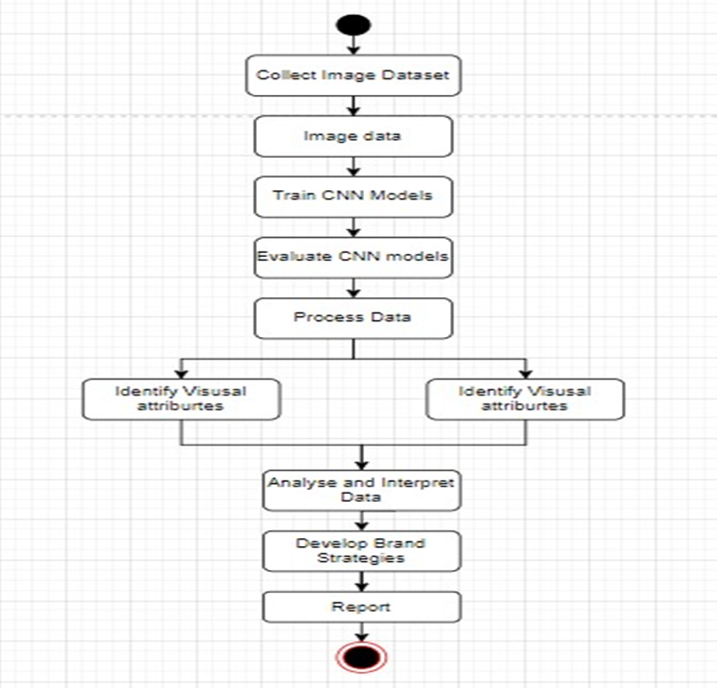

Fig 3. Activity Diagram

# Implementation

Our research focused on the development of a deep learning model using a hotel-image classification dataset. The objective was to accurately classify hotel images based on their appearance and identify the common features and attributes associated with each class. This information can be used to suggest improvements and enhancements to make hotels more visually appealing to potential customers.

The dataset used for training the deep learning model consisted of diverse images from different areas of hotels, such as balconies, bars, bathrooms, bedrooms, business centers, dining rooms, exteriors, gyms, living rooms, lobbies, patios, pools, restaurants, saunas, and spas. These classes represent various aspects of hotel environments and amenities.

The classification model was developed using convolutional neural networks (CNNs), which excel at extracting meaningful features from images. By leveraging deep learning and image classification techniques, our research aimed to gain insights into the appearance-based attributes of hotel images. Understanding the frequent classes and their corresponding features can help hotels make informed decisions to enhance their visual appeal and attract a broader customer base.

## Proposed Approach

In the proposed approach, we aim to classify hotel images into different categories using a custom CNN model. The model is trained on a dataset of hotel images, and the classification task involves predicting the corresponding hotel feature or area based on the visual content of the image.

## Models Used:

We have used 5 models in this project.

### AlexNet:

Motivation: AlexNet was developed to overcome the limitations of traditional methods in image classification and promote the use of deep learning in computer vision. The motivation was to leverage the power of deep convolutional neural networks to achieve breakthrough performance.

Architecture: AlexNet introduced several key architectural elements, including the use of multiple convolutional layers, ReLU activation functions, local response normalization, and dropout regularization. It utilized a larger model with more parameters to capture complex features in images.

Performance: AlexNet achieved significant improvements in accuracy on benchmark datasets, outperforming traditional methods and demonstrating the potential of deep learning in image classification.

### MobileNet:

Motivation: MobileNet was developed to address the need for efficient deep learning models that can run on resource-constrained devices such as mobile phones and embedded systems. The motivation was to enable real-time inference on devices with limited computational resources.

Architecture: MobileNet utilizes depthwise separable convolutions, which split the convolutional operation into a depthwise convolution followed by a pointwise convolution. This reduces the number of parameters and computations required while maintaining reasonable accuracy.

Performance: MobileNet achieves a good balance between model size and accuracy. It has demonstrated competitive performance on benchmark datasets, showcasing its efficiency compared to larger architectures.

### ResNet50:

Motivation: ResNet50 was developed to address the challenge of training very deep neural networks. The motivation was to overcome the degradation problem, where adding more layers leads to diminishing performance due to difficulties in optimizing deep networks.

Architecture: ResNet50 introduced the concept of residual blocks, which utilize skip connections to bypass a few layers. These connections allow gradients to flow directly, addressing the degradation problem. The architecture consists of many layers, including convolutional, pooling, and fully connected layers.

Performance: ResNet50 achieved outstanding performance on benchmark datasets, significantly reducing the error rate compared to previous architectures. Its skip connections enable the training of very deep networks with improved accuracy and convergence.

### VGG16:

Motivation: VGG16 aimed to investigate the impact of network depth on image classification performance. The motivation was to explore the relationship between model capacity and performance by increasing the number of layers while maintaining a simple and uniform architecture.

Architecture: VGG16 consists of many layers, mainly comprising small convolutional filters with max-pooling layers in between. It emphasizes deeper networks by stacking multiple layers and maintaining a consistent architecture throughout the network.

Performance: VGG16 achieved competitive performance on benchmark datasets, showcasing the importance of depth in capturing intricate image features. It provided insights into the relationship between model capacity and performance, paving the way for subsequent architectures.

These architectures were chosen based on their unique contributions to the field of deep learning, their success on benchmark datasets, and their relevance to the specific objectives of the project. They have demonstrated strong performance in image classification tasks and have been widely adopted and studied by the research community.

## Training and Hyperparameter Settings

The proposed approach employs the Adam optimizer during training, dynamically adjusting the learning rate for each parameter. This optimizer combines adaptive learning rate methods and momentum-based optimization, contributing to efficient and effective training of deep neural networks. The training process utilizes mini-batches of images and labels, allowing for efficient resource utilization and improved generalization. Each iteration involves a forward pass through the model, computing predicted class probabilities, which are compared to true labels using the CrossEntropyLoss function. Backpropagation is then performed to compute gradients for parameter updates, minimizing the loss function. Multiple epochs, encompassing complete passes through the training dataset, aid in gradual learning and performance improvement. Hardware accelerators, such as GPUs, can be utilized to expedite training for deep models and large datasets.

# Custom Model Architecture

The proposed model architecture is based on a Convolutional Neural Network (CNN) known for its exceptional performance in image classification. It utilizes convolutional layers and ReLU activation functions to extract hierarchical features from images and learn discriminative representations. By applying learnable filters and introducing non-linearity, the model can effectively extract localized features and capture complex relationships between them.

The model architecture utilizes max-pooling layers to reduce the spatial dimensions of the feature maps and capture salient information. Max-pooling divides the feature maps into regions and selects the maximum value within each region, reducing complexity and providing translational invariance. By following a pattern of alternating convolutional and max-pooling layers, the architecture progressively increases the depth and abstractness of learned features, enabling the model to capture both low-level and high-level visual patterns.

After the convolutional layers, the feature maps are flattened into a one-dimensional vector. This vector is then passed through fully connected layers, which act as a classifier. The fully connected layers combine the learned features and perform classification based on the patterns present in the feature representations. The final layer uses the softmax activation function to produce the predicted probabilities for each class, indicating the model's confidence in its predictions.

By utilizing the convolutional layers to extract meaningful features and the fully connected layers for classification, the proposed model architecture can effectively learn discriminative representations from the input images and make accurate predictions for the different classes in the dataset.

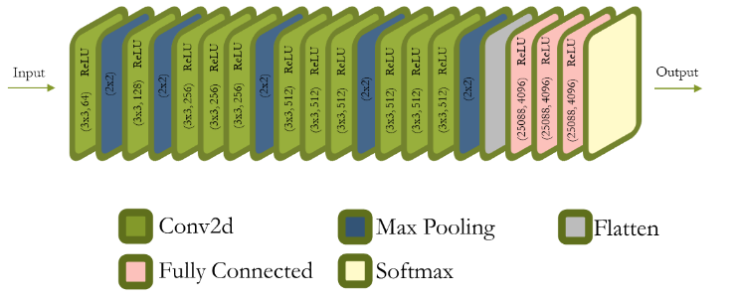

FIG 4. Layers of the custom model trained.

## Evaluation

After the completion of the training process, the model was evaluated on a separate test set to assess its generalization ability and performance. The test set consisted of unseen images that were not used during the training phase. The model's predictions were compared against the ground truth labels to measure its accuracy and effectiveness.

The evaluation of the model on the test set yielded the following results:

- Accuracy: 93.86%

- F1 Score: 0.9403

- Precision: 0.9358

- Recall: 0.9317

The high accuracy of 93.86% indicates that the model can accurately classify hotel images into their respective categories. The F1 score, which considers both precision and recall, reflects a balanced performance in terms of correctly classifying positive instances and identifying all positive instances in the test set. The precision score of 0.9358 means that when the model predicts a specific class, it is accurate approximately 93.58% of the time. The recall score of 0.9317 indicates that the model can correctly identify around 93.17% of the positive instances in the test set. These evaluation metrics demonstrate the effectiveness and robustness of the trained model in categorizing hotel images. The model's performance indicates its ability to generalize well to unseen data and make accurate predictions across different classes.

## Findings

The analysis of the test dataset classified by the custom model revealed interesting insights into the frequency and popularity of different image classes across hotels. Here are the key findings:

### Examples of Classified Images:

### The findings include a collection of example images from the test dataset, showcasing the model's classification results. These examples provide a visual representation of the model's performance in categorizing hotel images.

### Frequency of Images for Each Class:

### The findings present the frequency of images for each class in every hotel. This information gives an understanding of the distribution of different image classes within each hotel, highlighting the areas that are most photographed.

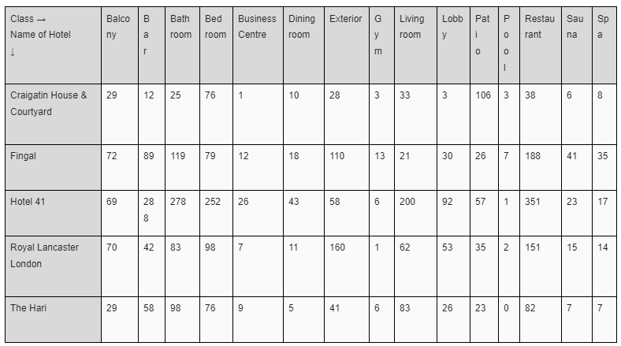

Table Frequency of images of each class for every hotel

Ten Most Photographed Classes per Hotel: The results summarize the findings related to the ten most photographed classes per hotel. By analyzing the frequency of images for each class, the report identifies the classes that are most commonly captured by hotel guests

Table Ten most photographed class for each hotel

Most Recurring Classes Overall: The findings report the most recurring classes considering the images of all the ten hotels. This analysis aggregates the image data across hotels to identify the classes that appear most frequently in the dataset.

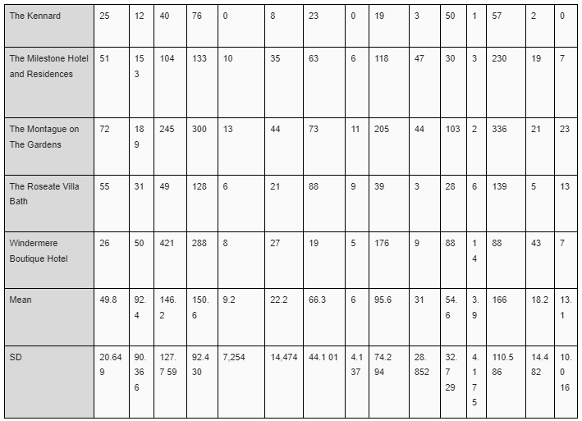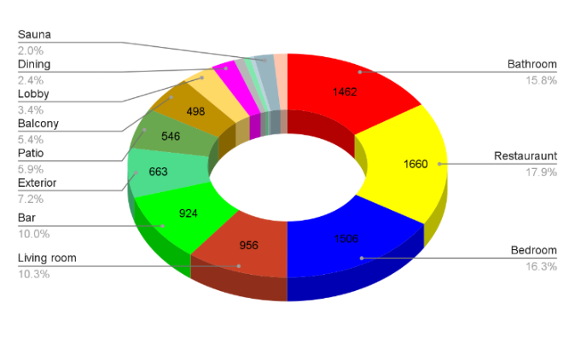

Fig 5 . Most recurring classes, considering the images of all the 10 hotels

### Popular Areas:

### The findings indicate that the restaurant class is the most photogenic area, followed by the bedroom and bathroom. This suggests that customers are particularly interested in seeing images of the hotel's dining facilities, rooms, and bathrooms.

### Attractive Features:

### The analysis also reveals that the bar and exterior of the hotels are highly attractive to customers. These areas generate significant interest and are frequently captured in the images of the hotels.

# Result and Analysis

|  |  |  |  |  |
| --- | --- | --- | --- | --- |
| Model | Accuracy | Precision | Recall | F1-score |
| Custom CNN Model | 93.86% | 0.9358 | 0.9317 | 0.9403 |
| ResNet | 92.71% | 0.9213 | 0.9237 | 0.9189 |
| AlexNet | 89.71% | 0.9012 | 0.8997 | 0.9039 |
| MobileNet | 92.68% | 0.9261 | 0.9132 | 0.9216 |
| VGG16 | 92.91% | 0.9253 | 0.9286 | 0.9316 |

Table Comparison of metrics of the four different CNN architectures trained

The custom model for hotel room image classification surpassed the performance of popular pre-trained models such as ResNet, AlexNet, MobileNet, and VGG16. It achieved higher F1-score and accuracy, indicating its effectiveness in capturing intricate patterns and making accurate predictions. The customization and architectural modifications tailored specifically for the task proved beneficial, surpassing the performance of ResNet, AlexNet, MobileNet, and VGG16. The inclusion of changes in the last dense layer, addition of a batch normalization layer, and additional convolutional and pooling layers allowed the custom model to learn more intricate representations and capture relevant hierarchical features, leading to its superiority.

The higher F1-score achieved by the custom model indicates its improved ability to balance precision and recall, resulting in accurate classification of hotel room types with minimal false negatives. This demonstrates the effectiveness of the custom model in correctly identifying positive instances. The superior performance of the custom model compared to well-established pre-trained models emphasizes the advantages of customization and fine-tuning for specific tasks. These results highlight the significance of tailoring the model architecture and training process to the specific domain, leading to superior performance in hotel room image classification.

# Applications

The hotel-image classification model developed in this research project has practical applications within the hospitality industry, including:

1. Hotel Image Classification: The model provides insights to hotel owners and managers about different areas of their property, streamlining marketing efforts, improving customer experience, and optimizing hotel operations.
2. Visual Content Analysis: The model can automatically tag and categorize hotel images, enhancing search and recommendation systems for travel agencies, online booking platforms, and review websites.
3. User-Generated Content Analysis: The model can analyze and classify user-submitted hotel images, providing insights into customer perceptions, identifying trends, and areas of improvement for hotels.
4. Competitor Analysis: The model can compare and analyze the facilities, amenities, and appearance of competing hotels, helping hotel owners and managers make data-driven decisions.
5. Personalization and Recommendation Systems: The model's output can be used to personalize recommendations for specific room types, amenities, or experiences, enhancing customer satisfaction and increasing bookings.

In summary, the hotel-image classification model has applications in marketing, customer experience, content analysis, competitor analysis, and personalization or recommendation systems, providing valuable insights and driving decision-making in the hospitality industry.

# Conclusion

# In this study, we compared the performance of a custom CNN model with four pretrained models (ResNet, AlexNet, MobileNet, and VGG16) on a hotel images dataset. The custom CNN model outperformed the pretrained models in terms of accuracy and F1-score, achieving 93.86% accuracy and an F1-score of 0.9403 on the test set. These results highlight the importance of designing a model architecture tailored to the specific task, as the custom CNN model's depth and complexity contributed to its superior performance. Fine-tuning the pretrained models on the hotel images dataset and exploring different hyperparameters could further enhance performance.

# Future Scope

## Expansion of Classifications: The current model can be expanded to include more specific subcategories, such as different types of hotel rooms, amenities, or architectural features. This fine-grained classification can provide detailed insights and enable better recommendations and personalization.

## Integration of User Feedback: Incorporating user feedback and reviews can enhance the accuracy and relevance of the model. Analyzing user sentiments and preferences expressed in reviews can improve the understanding and classification of hotel images, leading to better recommendations and personalized suggestions.

## Real-Time Image Classification: Developing a real-time image classification system would enable users to capture and upload hotel images directly from their mobile devices, providing instant classification results and recommendations. Real-time image classification can enhance user engagement and convenience.

## Integration with Booking Platforms: Integrating the model with popular booking platforms can allow automatic analysis and categorization of hotel images. Users can easily filter and sort hotels based on their preferences, streamlining the selection process and providing a more efficient and personalized booking experience.

## Continuous Model Training and Improvement: Regular model updates and improvements based on new data and user feedback can increase accuracy and adaptability. Continuous learning and refinement ensure the model stays relevant and effective in the dynamic hospitality industry.

These future scopes present exciting opportunities to enhance the hotel-image classification model, leading to improved user experiences, more accurate recommendations, and greater personalization in the hotel selection process.

# References

Hennigs, N., Wiedmann, K. P., Behrens, S., & Klarmann, C. (2013). Unleashing the power of luxury: Antecedents of luxury brand perception and effects on luxurybrand strength. Journal of Brand Management, 20(8), 705–715.

Atwal, G., & Williams, A. (2009). Luxury brand marketing–the experience is everything!. Journal of Brand Management, 16(5–6), 338–346.

E. Konijn, N. Sluimer and O. Mitas Int. J. Tour. Res., 18 (6) (2016), pp. 525-535.

2019. Chan, N. L., & Guillet, B. D. (2011). Investigation of social media marketing: How does the hotel industry in Hong Kong perform in marketing onsocial media websites? Journal of Travel & Tourism Marketing, 28(4), 345–368

Boo, S., & Busser, J. A. (2018). Meeting planners' online reviews of destination hotels: A twofold content analysis approach. Tourism Management, 66, 287–301.

Kim, J., & Lee, K. H. (2019). Influence of integration on interactivity in social media luxury brand communities. Journal of Business Research, 99, 422–429.

Tasci, A. D. A. (2018). Testing the cross-brand and cross-market validity of a consumer based brand equity (CBBE) model for destination brands. Tourism Management, 65, 143–159.

2019. Chan, N. L., & Guillet, B. D. (2011). Investigation of social media marketing: How does the hotel industry in Hong Kong perform in marketing on social media websites? Journal of Travel & Tourism Marketing, 28(4), 345–368.

Thelander, A., & Cassinger, C. (2017). Brand new images? Implications of Instagram photography for place branding. Media and Communication, 5(4), 6–14.

Hsu, L. C., Wang, K. Y., Chih, W. H., & Lin, K. Y. (2015). Investigating the ripple effect in virtual communities: An example of Facebook Fan Pages. Computers in Human Behavior, 51, 483–494.

Lim, J., Hwang, Y., Kim, S., & Biocca, F. (2015). How social media engagement leads to S. Giglio, et al. Journal of Business Research xxx (xxxx) xxx–xxx 6 sports channel loyalty: Mediating roles of social presence and channel commitment. Computers in Human Behavior, 46, 158–167.

Lee, D., Kim, H. S., & Kim, J. K. (2012). The role of self-construal in consumers' electronic word of mouth (eWOM) in social networking sites: A social cognitive approach. Computers in Human Behavior, 28(3), 1054–1062.

Chen, A., Lu, Y., Wang, B., Zhao, L., & Li, M. (2013). What drives content creation behavior on SNSs? A commitment perspective. Journal of Business Research, 66(12), 2529–2535.

Devereux, L., Melewar, T. C., & Foroudi, P. (2017). Corporate identity and social media: Existence and extension of the organization. International Studies of Management and Organization, 47(2), 110–134.

Swani, K., Milne, G. R., & Miller, E. G. (2019). Social media services branding: The use of corporate brand names. Journal of Business Research.

Balomenou, N., & Garrod, B. (2019). Photographs in tourism research: Prejudice, power, performance and participant-generated images. Tourism Management, 70, 201–217.

F. Girardin, F. Calabrese, F. Dal Fiore, C. Ratti and J. Blat IEEE Pervasive Comput., 7 (4) (2008).

Chollet, F. (2017). Xception: Deep Learning with Depthwise Separable Convolutions. In Proceedings of the IEEE Conference on Computer Vision and Pattern Recognition (CVPR) (pp. 1251-1258).

Tan, M., & Le, Q. V. (2019). EfficientNet: Rethinking Model Scaling for Convolutional Neural Networks. In Proceedings of the 36th International Conference on Machine Learning (ICML) (Vol. 97, pp. 6105-6114).

Image Classification Algorithm Based on Improved AlexNetShaojuan Li1, Lizhi Wang1, Jia Li1 and Yuan Yao. Published under licence by IOP Publishing Ltd Journal of Physics: Conference Series, Volume 1813, 2020 International Conference on Modeling, Big Data Analytics and Simulation (MBDAS2020) 20-21 December 2020, Xiamen, China